HW3

River Schenck

Skyler Judson

Chibuike Chikere-Njoku

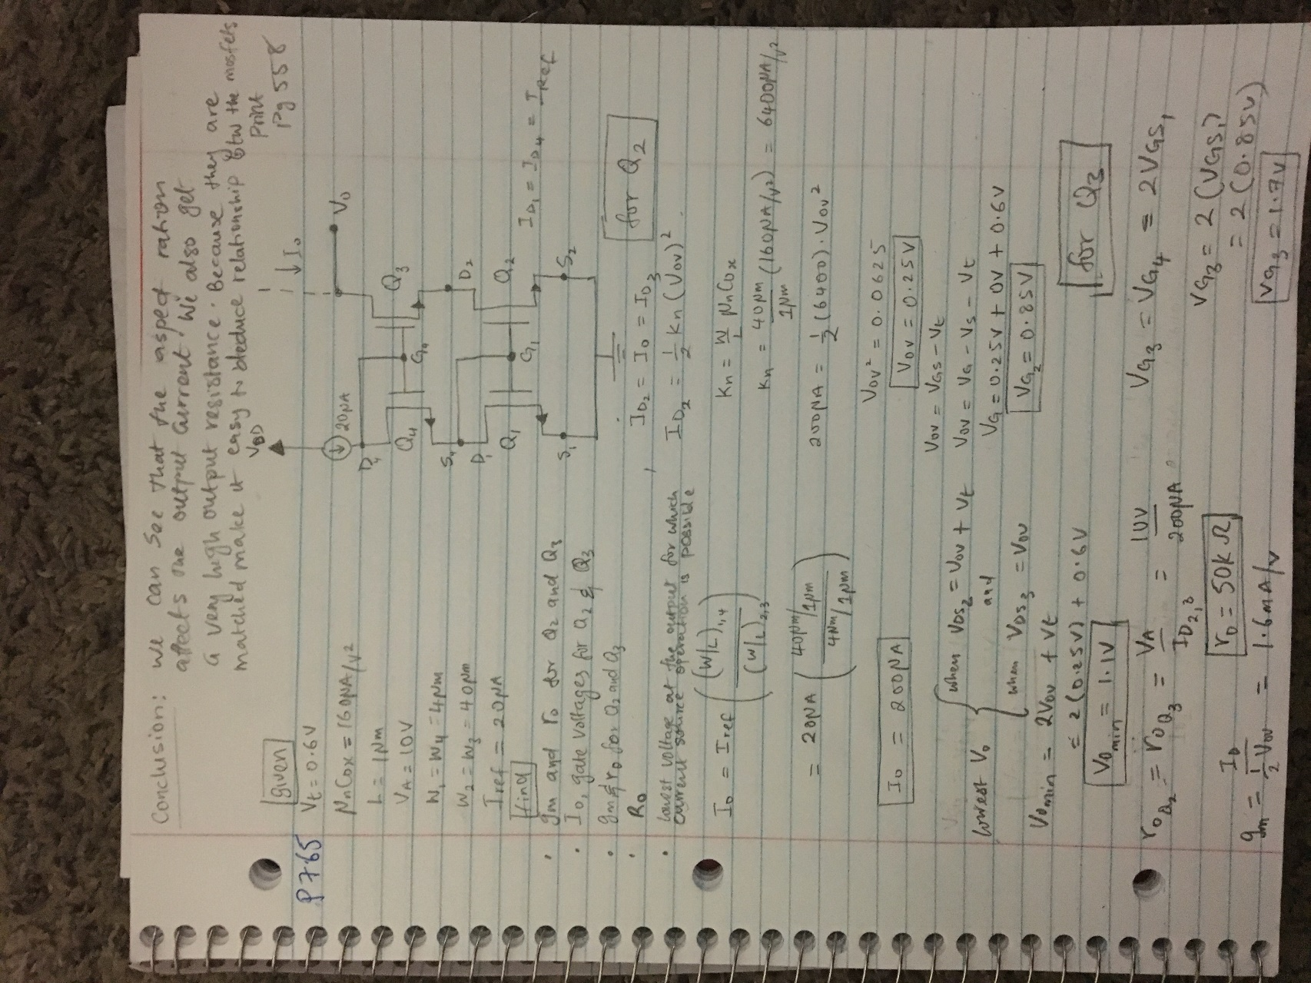

P7.65 simulation

The change in current when changing the output voltage to 10 v is zero

As you can see in the picture below Io is about 10\*Iref

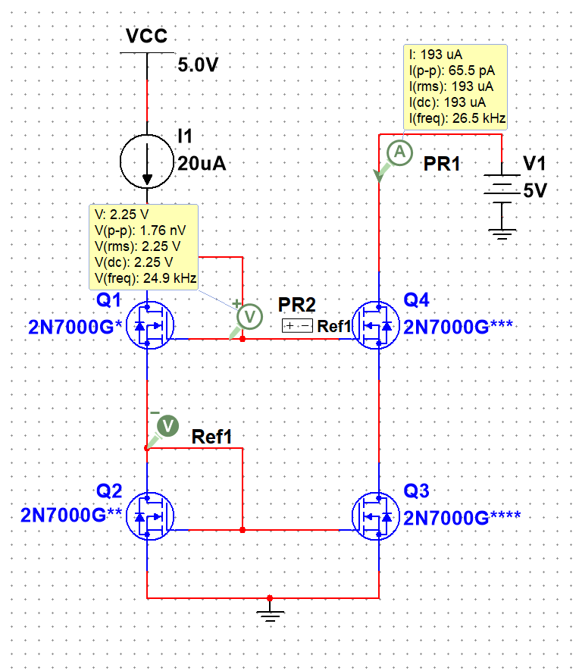

Resistor that replaces current source

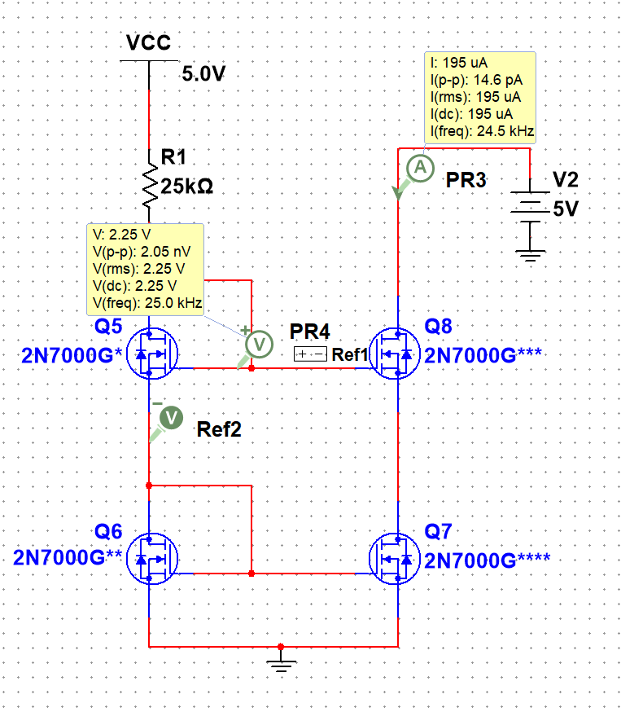

Io vs Vo curve

